

Introduction
This project is about TV shows dataset which includes title, year, rating, IMDB score and Netflix availability. The data is analyzed using MySQL and Power BI.

About Dataset
This dataset contains a curated list of popular TV shows along with their key attributes such as release year, audience classification, IMDb ratings, and availability on Netflix. It is designed for data analysis, visualization, and machine learning applications in the domain of entertainment and streaming platforms.
The dataset enables users to explore trends in content quality, audience targeting, and platform distribution, making it ideal for beginners and intermediate learners in data science.

Use Cases
- Exploratory Data Analysis (EDA)
- Data visualization and storytelling
- Content rating and popularity analysis
- Netflix vs Non-Netflix comparison
- Beginner-level machine learning projects

Key Highlights
- Includes both Netflix and non-Netflix TV shows
- Covers highly rated and popular series
- Simple and clean structure for easy analysis
- Suitable for learning data science concepts

EER Diagram Section
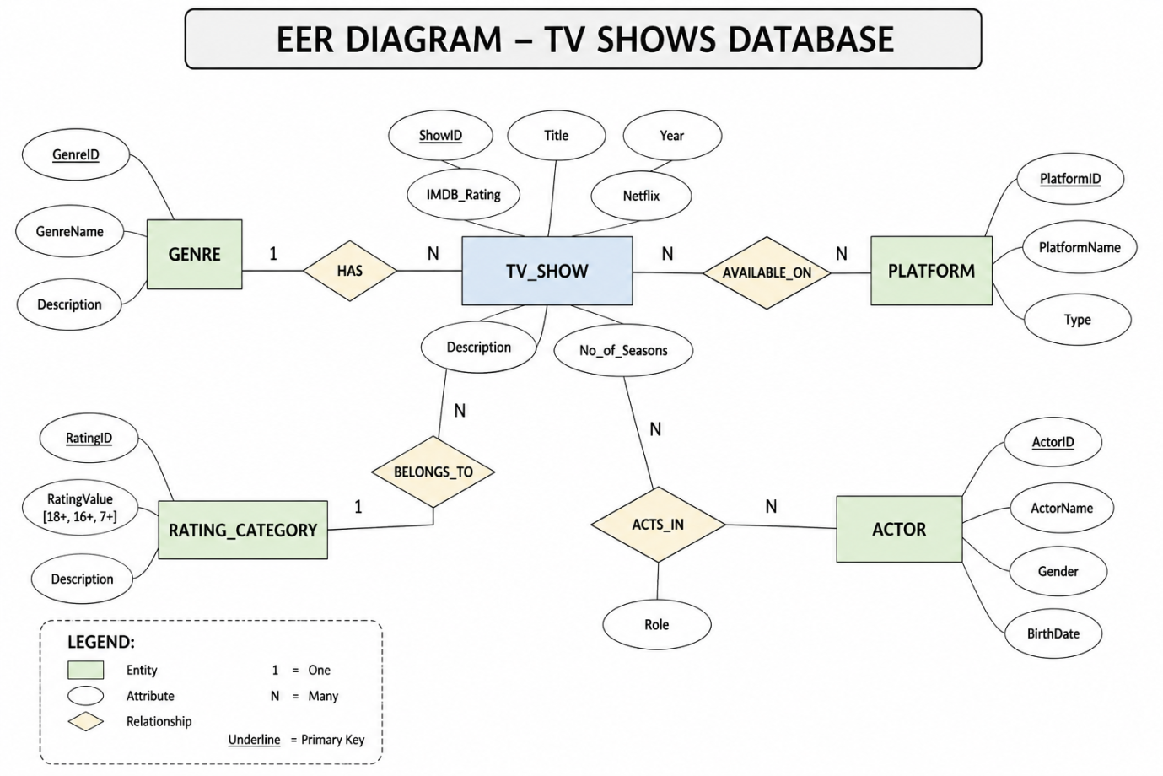

MySQL Work
• Database created
• Table created
• Data inserted
• Queries used

MySQL work step by step:

Step 1: Database create
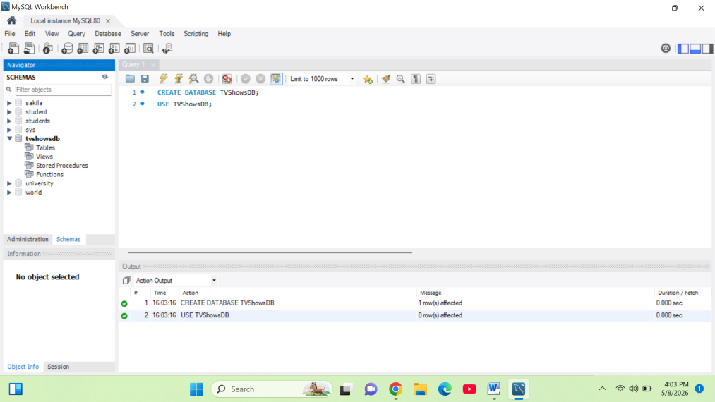

Step 2: Table create:
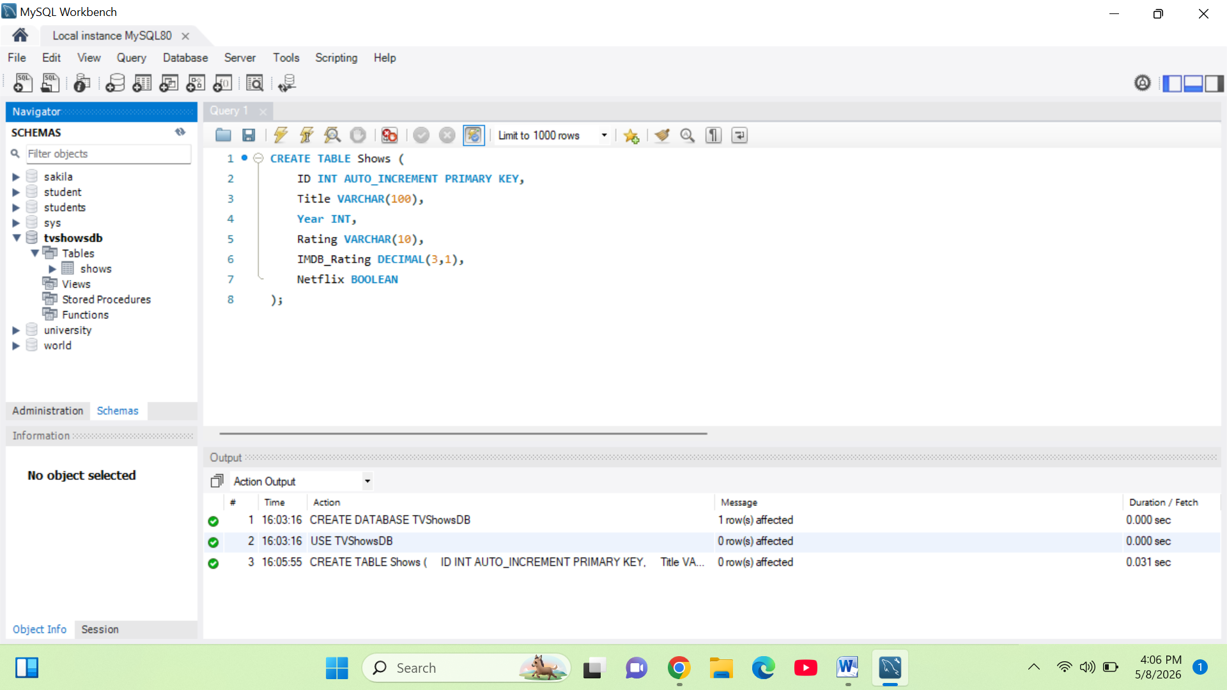
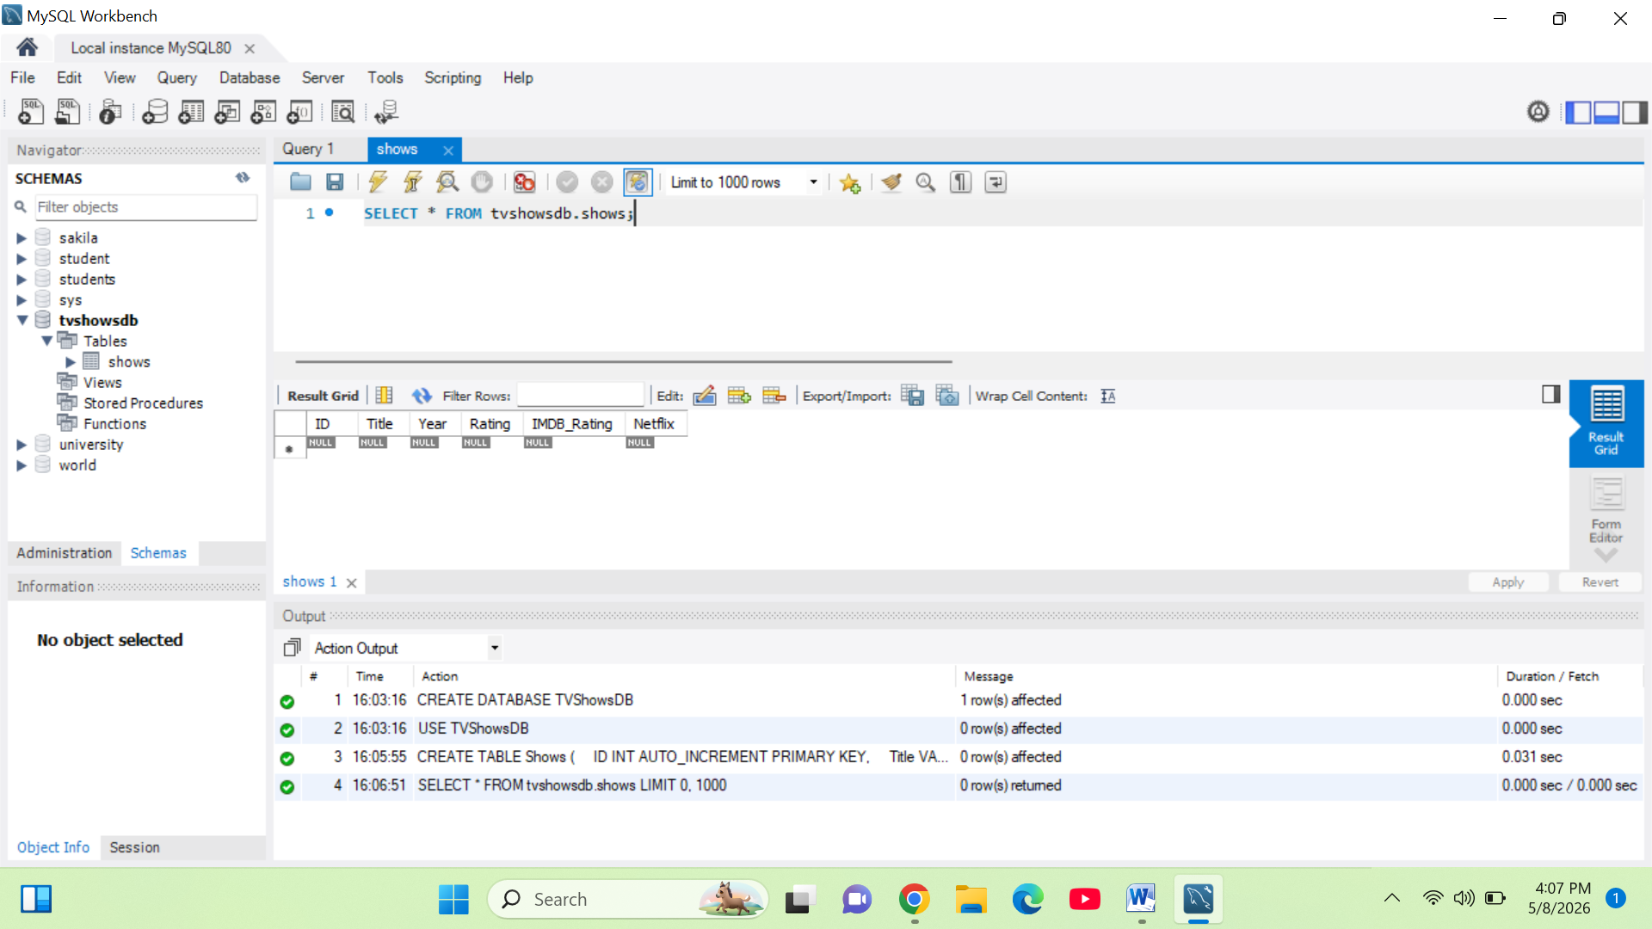

Step 3: Data insert:

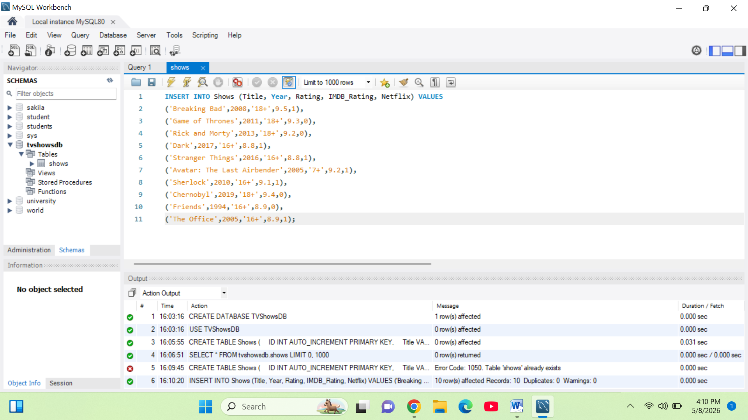

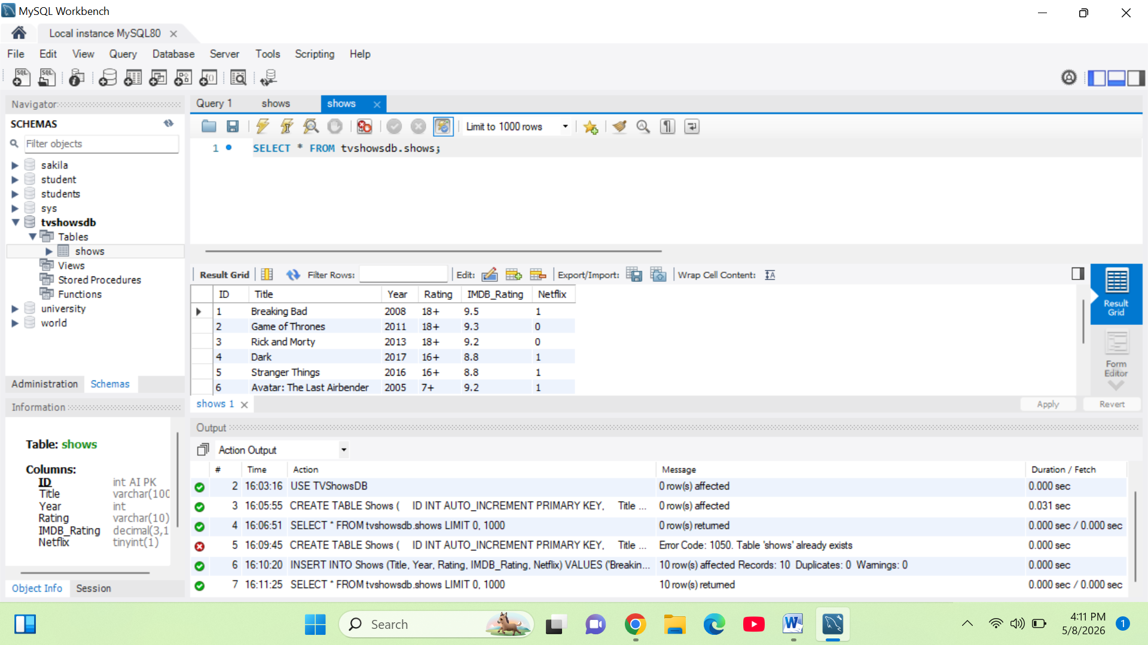

Important Queries:
  - All shows



2. Highest rated shows

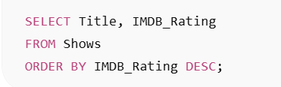

3. Only Netflix shows

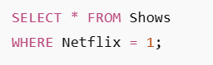

4. Average rating

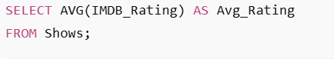

5. Year wise count



Power BI Section:
• Data imported
• Transform data used
• Charts created:
• Bar Chart (Ratings comparison)
• Pie Chart (Netflix vs Not Netflix)
• Column Chart (Yearly analysis)
• Card (Average Rating)
Bar Chart:

Purpose of Bar Chart
1.A bar chart is used to compare the IMDB ratings of different TV shows.
2.This Bar Chart visualizes the IMDB Ratings of various Netflix TV Shows, allowing for a quick comparison of content quality across different titles.

How it works
- X-Axis: IMDB_Rating
- Y-Axis: Titles
Why Bar Chart is Used
Bar chart helps to:
- Compare TV shows easily
- Identify highest rated shows
- Analyze popularity of shows
- Present data in visual form

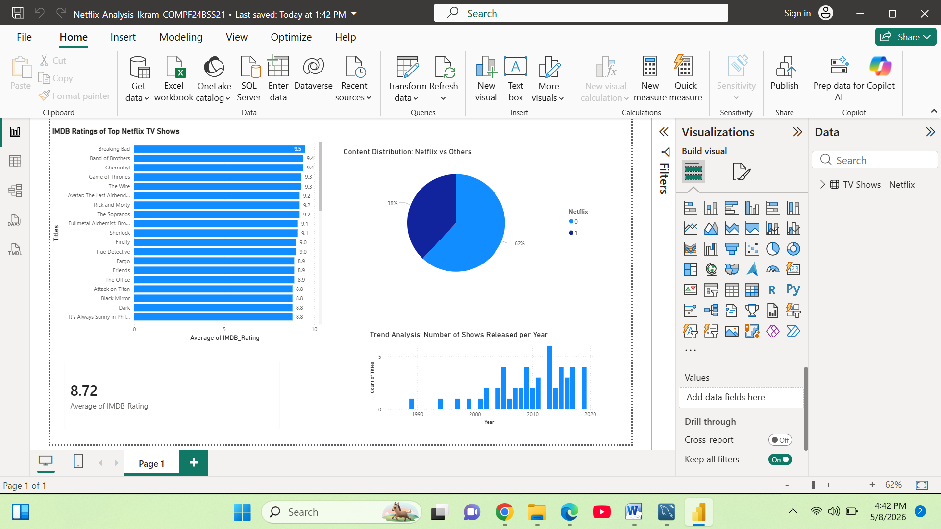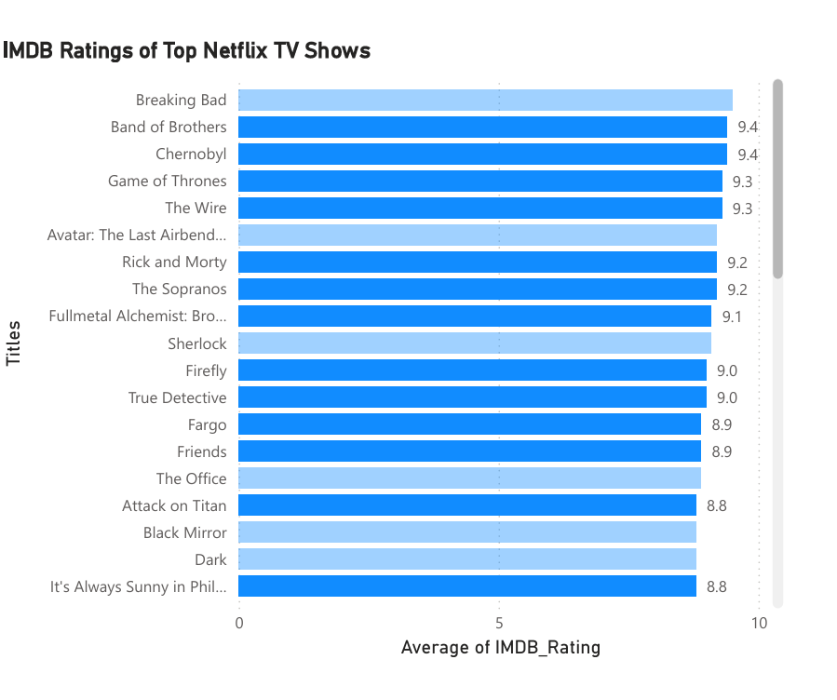

Pie Chart:

Purpose:
This chart shows the percentage distribution of Netflix and non-Netflix shows.

How it works:
- Netflix = 1 (Available)
- Netflix = 0 (Not Available)

Why used:
It helps in understanding:
- How many shows are available on Netflix
- How many are not available

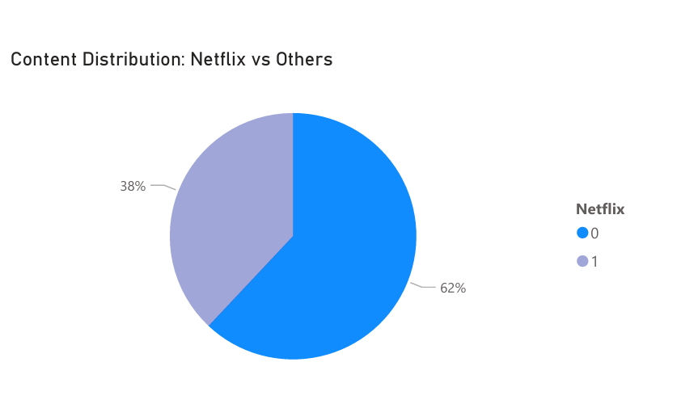
Column Chart

Purpose:
This chart is used to analyze trends over time.

How it works:
- X-Axis = Year
- Y-Axis = Count of Titles

Why used:
It helps to identify:
- Rating trends over years
- Improvement or decline in show quality



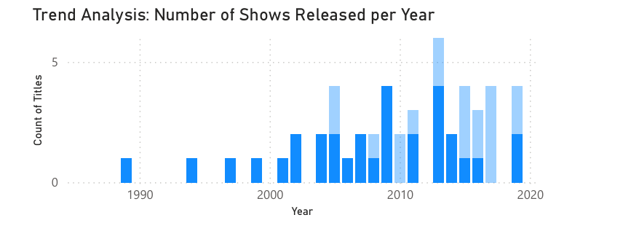

Card Visual

Purpose:
Card visual displays important summary information.

Example:
- Total TV Shows
- Average IMDB Rating
- Total Netflix Shows

Why used:
It gives quick insights without reading full charts.



